**COMP9331 LAB2 – HTTP and Socket Programming**

Changfeng LI(z5137858)

**Exercise 1,2: (not needed in the report)**

**Exercise 3: Using Wireshark to understand basic HTTP request/response messages**

Qs3-1: What is the status code and phrase returned from the server to the client browser?

Qs3-2: When was the HTML file that the browser is retrieving last modified at the server? Does the response also contain a DATE header? How are these two fields different?

Qs3-3: Is the connection established between the browser and the server persistent or non-persistent? How can you infer this?

Qs3-4: How many bytes of content are being returned to the browser?

Qs3-5: What is the data contained inside the HTTP response packet?

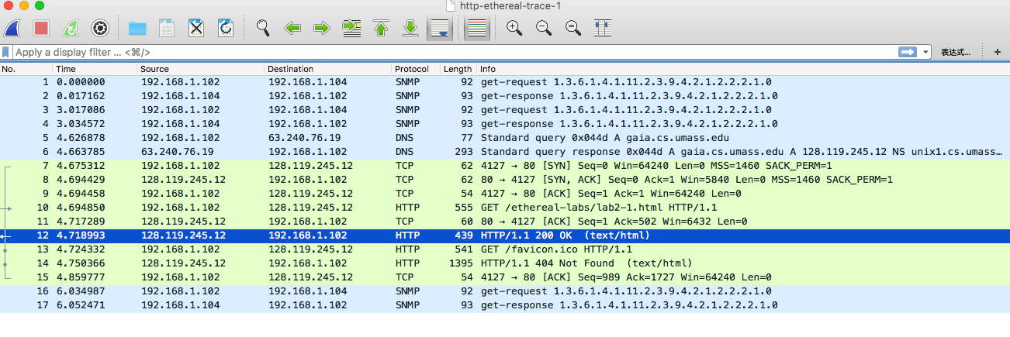

As3-1: From the first two messages of HTTP get and response(10 & 12)

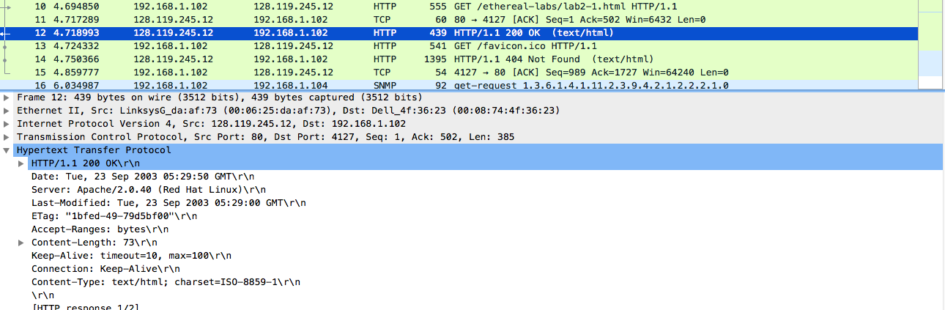

We can see that status code is 200, and response phrase is OK.

As3-2:

• The last modified time of The HTML file is Tue, 23 Sep 2003 05:29:00 GMT

• Correct.

• The info in Date header means the time when the messages was sent, but last modified time means the last time that HTML was modified.

As3-3: The connection is persistent. Because the property of the connection is “keep-alive”. This means numerous HTTP requests and responses are handled by one TCP connection.

As3-4: 73

As3-5: HTML source code and text information.

<html>\n

Congratulations. You’ve downloaded the file lab2-1.html!\n

<html>\n

**Exercise 4: Using Wireshark to understand the HTTP CONDITIONAL GET/response interaction**

Qs4-1: Inspect the contents of the first HTTP GET request from the browser to the server. Do you see an “IF-MODIFIED-SINCE” line in the HTTP GET?

Qs4-2: Does the response indicate the last time that the requested file was modified?

Qs4-3: Now inspect the contents of the second HTTP GET request from the browser to the server. Do you see an “IF-MODIFIED-SINCE:” and “IF-NONE-MATCH” lines in the HTTP GET? If so, what information is contained in these header lines?

Qs4-4: What is the HTTP status code and phrase returned from the server in response to this second HTTP GET? Did the server explicitly return the contents of the file? Explain.

Qs4-5: What is the value of the Etag field in the 2nd response message and how it is used? Has this value changed since the 1 st response message was received?

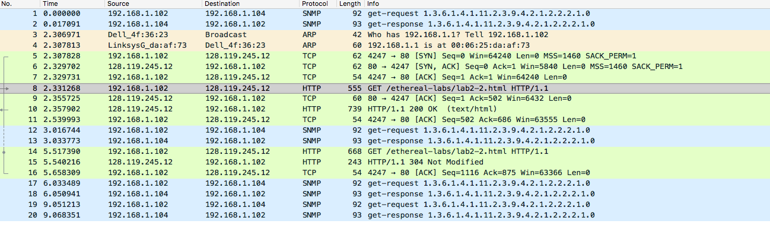

As4-1:

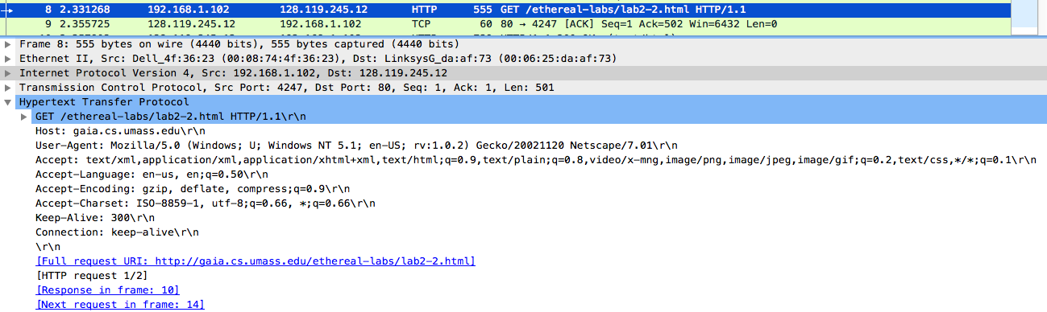

We can draw a conclusion that there exists no “IF-MODIFIED-SINCE” lines.

As4-2:



Observing the information in line 14, we find that the last modified time field reveals the time is Tue, 23 Sep 2003 05:35:00 GMT. But the second requests indicates any further modifications.

As4-3: All information are included in the header.

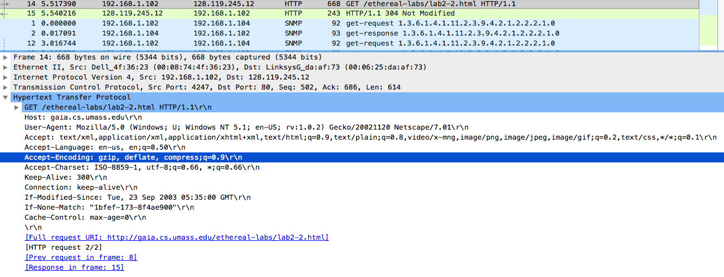

As4-4:

• The status code is 304, the response phrase is ‘Not Modified’.

• This means this file is not returned by that server because it has not been modified.

• The fact that this happens is that “GET” request is a conditional request which is determined by the fact whether the file has been modified last time.

• The main benefit of 304 status information is to help save bandwidth because it rid of the situation that the server send back a whole message everytime.

As4-5:

• ETag field: ETag: “1bfef-173-8f4ae900”\r\n.

• ETag can help user make efficient requests, which means that if a server visit the same site, the client(browser) will send the request which only contains Last-modified and ETag information. This means the server avoids full response everytime.

**Exercise 5: (only code)**